



FUNDAMENTAL SPREADSHEET APPLICATIONS
(230)
STATE 2021

Production:
Job 1: Create Spreadsheet with Formulas __________ (175 points)
Job 2: Format Spreadsheet __________ (135 points)
Job 3: Create Pivot Table and Pivot Table Chart __________ (50 points)
TOTAL POINTS __________ (360 points)

Test Time: 90 minutes

GENERAL GUIDELINES:
Failure to adhere to any of the following rules will result in disqualification:
- Contestant must hand in this test booklet and all printouts if any. Failure to do so will result in disqualification.
- No equipment, supplies, or materials other than those specified for this event are allowed in the testing area. No previous BPA tests and/or sample tests (handwritten, photocopied, or keyed) are allowed in the testing area.
- Electronic devices will be monitored according to ACT standards.

GENERAL INSTRUCTIONS:
- Put your contestant number and printout number in the right section of the footer on each printout unless instructed otherwise. Your name or initials should not appear on any work you submit.
- If you finish before the end of the testing time, notify the proctor. Time may be a factor in determining the winner in the event of a tie.
- When turning in your contest, the jobs should be arranged in printout order.

SCENARIO:
You are a student aide in the front office of BPA HS. Your job today is to create a spreadsheet for one of the teachers that contains data on hall pass usage for her classes for the month of November.
GRADER: Points are all or none unless otherwise noted.
Job 1 (Worksheet with Formulas) | Points Possible | Points Earned
Contestant # and Job # in right section of footer | 10
11 pt. Times New Roman font used for data | 10
Set to Landscape Orientation | 5
Spreadsheet information entered | 10
Formula entered in cell G3 that calculates the total time each student is out of class (Answers will not be in time format – that formatting takes place in Job 2). | 10
Formula copied down to row 20 | 10
Updated spreadsheet with the December information (rows 21-24) | 10
Updated the formulas to include the December data | 10
The following information was entered in the cells listed:  - A26: How many passes to:  - A27: Bathroom  - A28: Office  - A29: Nurse | 20
Function entered in Cell B27 that counts the number of bathroom visits | 10
Function entered in Cell B28 that counts the number of office visits | 10
Function entered in Cell B29 that counts the number of nurse visits | 10
In cell D27 entered the following information: “longest time out of class for one student” | 5
In cell G27, entered a function that finds the longest time a student was out of class | 10
Renamed the worksheet Mr. Norris | 5
Centered vertically and horizontally on one page | 10
Printout is in landscape view with the worksheet centered on the page | 10
Printout of formulas in landscape view with the worksheet centered on one page | 10
Subtotal | 175

Job 2 (Formatted Worksheets) | Points Possible | Points Earned
Contestant # and Job # in right section of footer | 10
Printed in landscape, centered vertically and horizontally on one sheet | 10
Formatted A1 to merge center across the data | 10
Increased the font size of the title to 20 | 5
Placed a thick bottom border under the title | 5
Formatted G3:B27 to “time” with XX-XX-XX format | 10
Bolded the column titles (Date, In, Location, Etc.) | 10
G3:G24 use conditional formatting as follows:  - Icon Set 3 arrows (gray)  (After typing in the information, it will convert the time to a number)  - Up arrow: >0:15:00  - Middle arrow: 0:10:00 | 15
Created a second conditional formatting on the same cell locations to highlight in yellow for any times greater than 0:15:00 minutes. | 10
Made a copy of your worksheet and renamed the new worksheet: Mr. Norris subtotal | 5
On the new worksheet, do a custom sort on first name | 5
Subtotal the data, change in first name, function count and subtotal on the total only | 15
Updated the function in cell G34 to include the total time cells for students, not the count cells | 10
Formatted this page to only print on one sheet at 93% normal size | 10
Printout of the two formatted spreadsheets centered horizontally and vertically on one page | 5
Subtotal | 135

Job 3 (Pivot Table and Pivot Chart) | Points Possible | Points Earned
Contestant # and Job # in right section of footer | 10
Based on Mr. Norris spreadsheet, a Pivot Table and Pivot Chart were created with the following fields:  - Location: Legend series  - First Name: Axis category  - Total: Values (minutes and hours off) | 15
Placed in new worksheet; renamed Pivot Table and Chart | 10
Chart moved so the top left corner is in Cell B13 | 5
Centered vertically and horizontally on one page | 10
Subtotal | 50
TOTAL POINTS | 360

Job 1 Unformatted
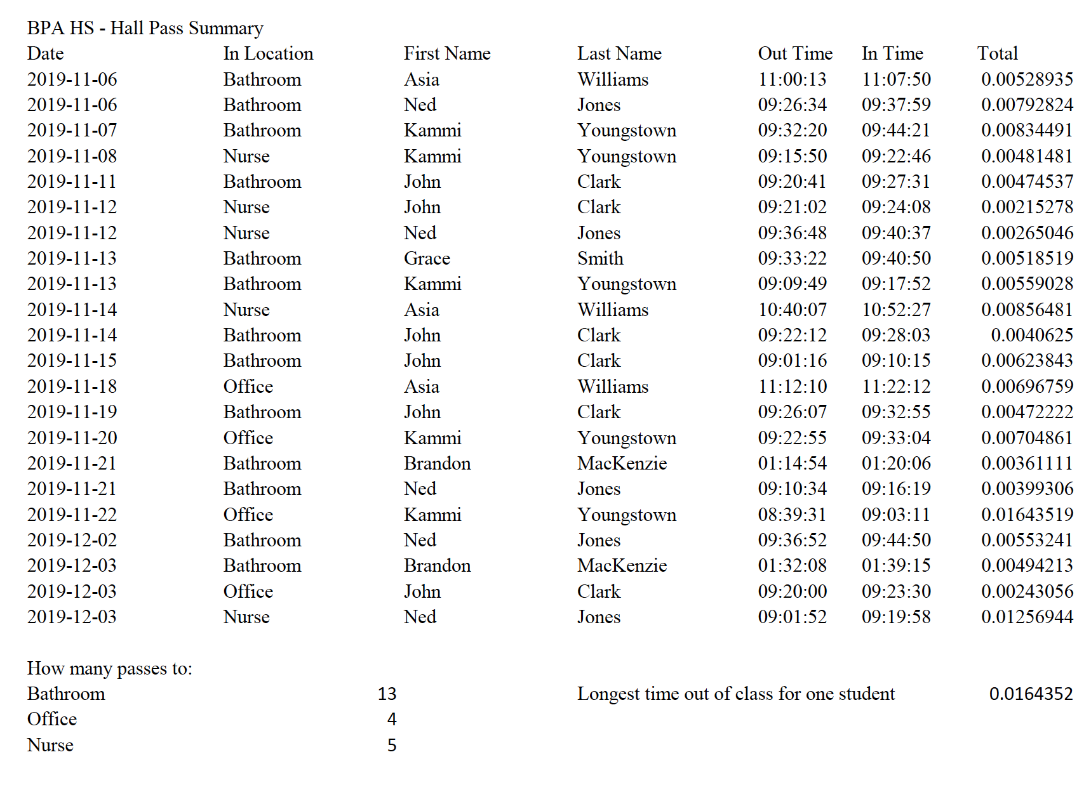

Job 1 Formulas
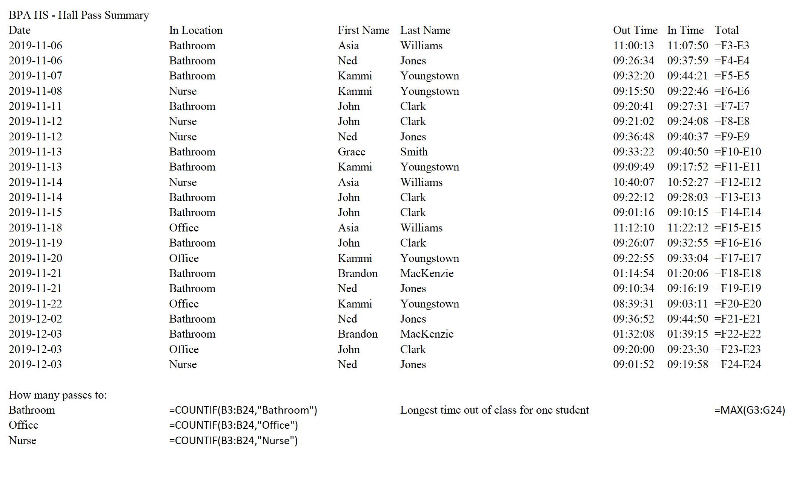

Job 2 Formatted with Subtotals
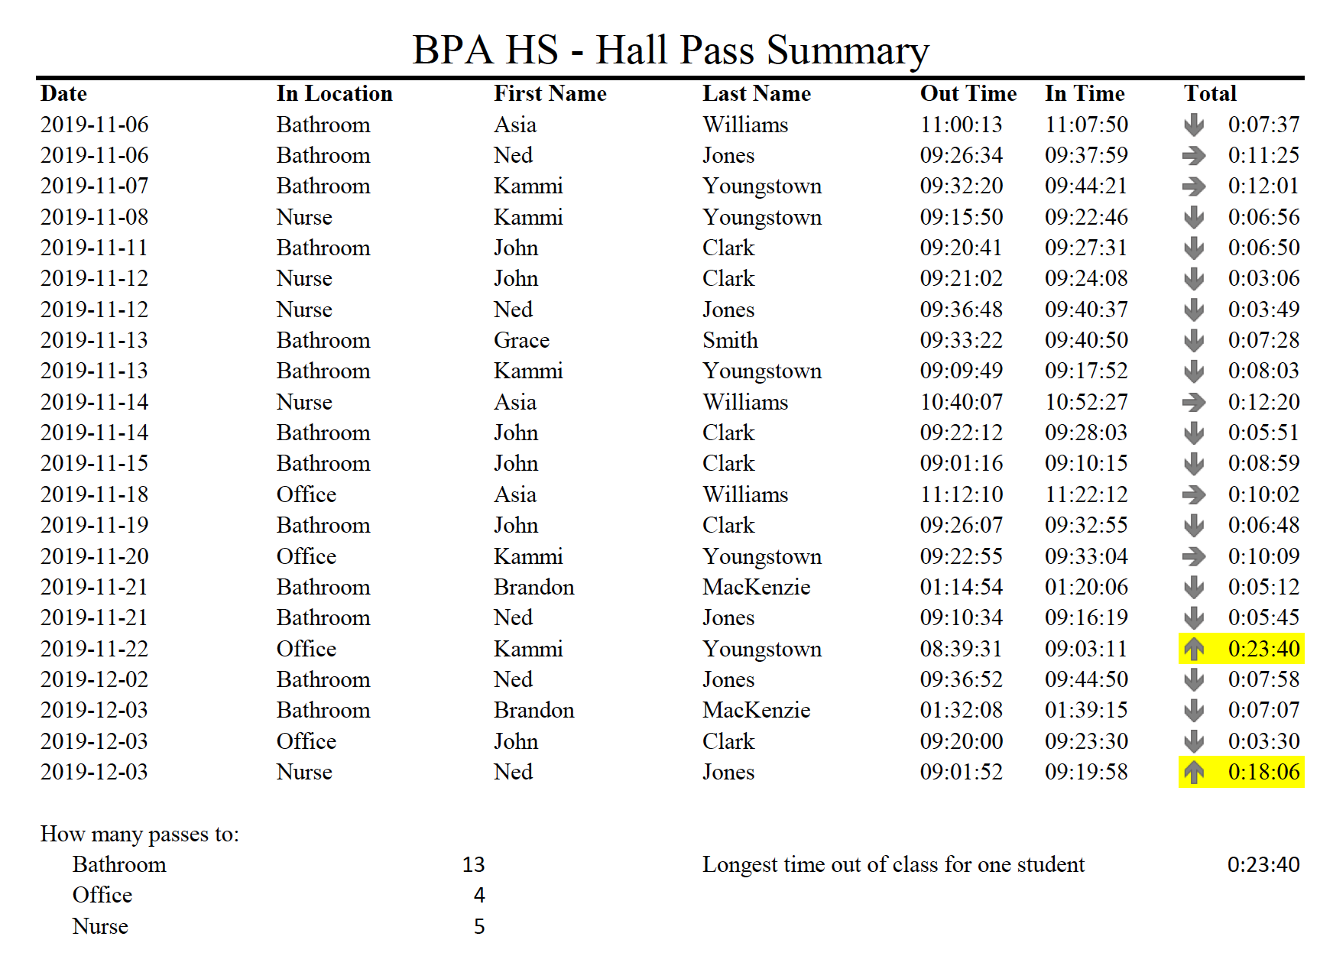

Job 2 Formatted
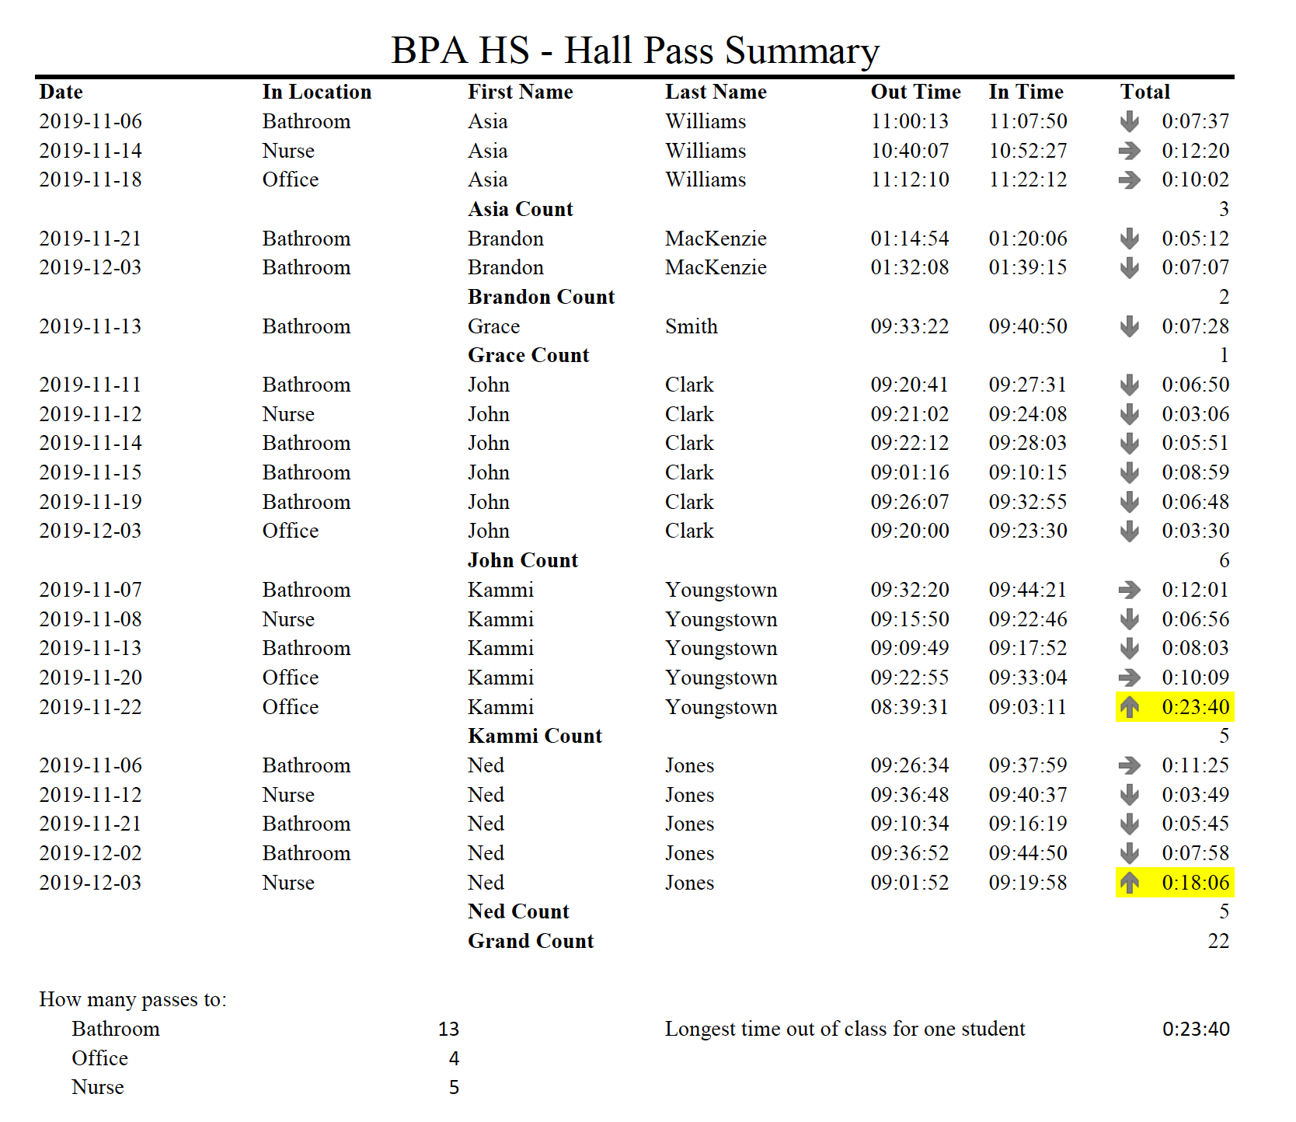
Job 3 Pivot Table and Pivot Chart